## 

|  |
| --- |
| **International School**  CAPSTONE PROJECT 2  **CMU-SE-451**  INTERFACE DESIGN DOCUMENT  Version 1.2  Date: 7 – May - 2022  GreenBig5 Information System  Submitted by  Loc, Nguyen Tien  Chung, Hoang Bao  Vinh, Do Quang  Kha, Ngo Van  **Approved by**  **Capstone Project 2 - Mentor:**  Name Signature Date  Nguyen Thanh Binh  15.05.2022 |

|  |  |  |  |
| --- | --- | --- | --- |
| **PROJECT INFORMATION** | | | |
| **Project Acronym** | GB5 | | |
| **Project Title** | GreenBig5 | | |
| **Project Web URL** | [http://greenbig5.herokuapp.com/](about:blank) | | |
| **Start Date** | 1 - March - 2022 | | |
| **End Date:** |  | | |
| **Lead Institution** | International School, Duy Tan University | | |
| **Project Mentor** | Doctor. Habil. Binh, Thanh Nguyen | | |
| **Scrum Master** | Loc, Nguyen Tien | nguyentienloc18122000@gmail.com | 0932.478.789 |
| **Team Members** | Chung, Bao Hoang | baochunga1@gmail.com | 0889.192.932 |
| Vinh, Do Quang | doquangvinh0708co@gmail.com | 0236.351.9169 |
| Kha, Ngo Van | ngokha437@gmail.com | 0935.950.384 |

|  |  |  |  |
| --- | --- | --- | --- |
| **DOCUMENT INFORMATION** | | | |
| **Document Title** | Interface Design Document | | |
| **Author(s)** | Team C2SE.32 | | |
| **Role** | [GB5] Interface\_Design\_v2.0 | | |
| **Date** | 1 - March - 2022 | File name | [GB5] Interface\_Design\_v2.0 |
| **URL** | http://greenbig5.herokuapp.com/ | | |
| **Access** | Project and CMU Program | | |

## REVISION HISTORY

|  |  |  |  |  |
| --- | --- | --- | --- | --- |
| **Version** | **Person(s)** | **Date** | **Description** | **Approval** |
| 1.0 | Kha | 1-March-2022 | Update Design UX/UI Web & app | x |
| 1.1 | Kha | 8-April -2022 | Update interface app | x |
| 1.2 | Kha | 7-May-2022 | Update interface web | x |

## TABLE OF CONTENTS

[REVISION HISTORY 2](#_Toc103531374)

[TABLE OF CONTENTS 3](#_Toc103531375)

[1. INTRODUCTION 4](#_Toc103531376)

[1.1. PURPOSE OF DOCUMENT 4](#_Toc103531377)

[1.2. INTENDED AUDIENCES 4](#_Toc103531378)

[1.3. DOCUMENT OVERVIEW 4](#_Toc103531379)

[2. DETAILED INTERFACE WEB DESIGN 5](#_Toc103531380)

[2.1. Loginpage 5](#_Toc103531381)

[2.2. Sidebar 7](#_Toc103531382)

[2.3. Dashboard page 8](#_Toc103531383)

[2.4. User page 10](#_Toc103531384)

[3. DETAILED INTERFACE APPLICATION DESIGN 11](#_Toc103531385)

[3.1. Sign In page 11](#_Toc103531386)

[3.2. Signup page 13](#_Toc103531388)

[3.3. User information page 15](#_Toc103531389)

[3.4. Change DisplayName, PhoneNumber page 17](#_Toc103531390)

[3.5. Question page 18](#_Toc103531391)

[3.5. Logout 20](#_Toc103531392)

[4. DETAILED INTERFACE QUESTION WEB DESIGN 22](#_Toc103531393)

[4.1 Home page 22](#_Toc103531394)

[4.2 Navbar 23](#_Toc103531395)

[4.3 Notification 24](#_Toc103531396)

# INTRODUCTION

## PURPOSE OF DOCUMENT

This IDD of the GB5 system has the following purpose:

* Document the design of the user interface of functions of GB5.
* Be the primary document driving the implementation of the user interfaces.
* Introduce interface design for the reader. Including the background, content information display, command buttons.

## INTENDED AUDIENCES

This IDD is intended for the following audiences:

* Technical reviewers including:
* Scrum Master
* Product owner
* Implementers, including:
  + Developers.
  + Testers.

## DOCUMENT OVERVIEW

This IDD is organized into the following sections:

* This document helps to better understand the interface of the Green Big 5 information System, detailed specification components and function of the Application, Dashboard
* With this document, the development team can understand the structure and composition to create a consistent and complete system.
* Overview of the stages and modules of the software and create a complete interface.

# DETAILED INTERFACE WEB DESIGN

## Login page

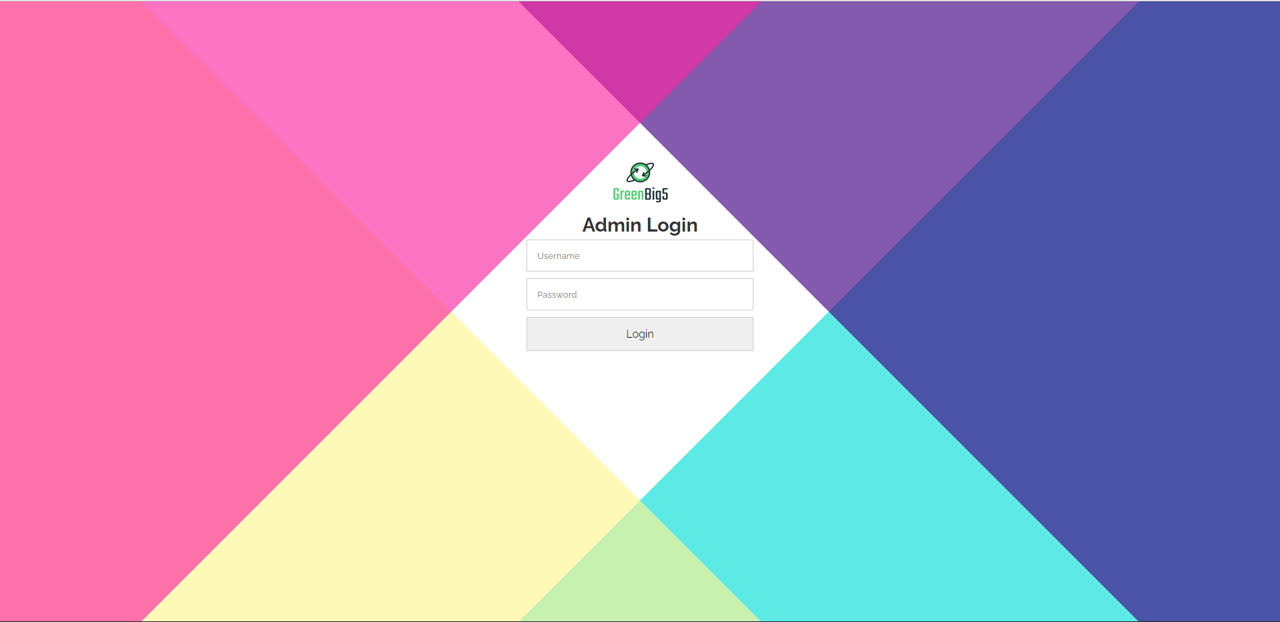

|  |  |  |  |  |
| --- | --- | --- | --- | --- |
| **Login page** | | | | |
| **No.** | **Field name** | **Type** | **Require** | **Target** |
| 1 | Background |  | .top:before {  transform: rotate(45deg);  background: #05dfd7;  }  .top:after {  transform: rotate(135deg);  background: #fff591;  }  .bottom:before {  transform: rotate(-45deg);  background: #400082;  }  .bottom:after {  transform: rotate(-135deg);  background: #fa26a0; |  |
| 2 | Header | H2 tag | Font-size: 1.2rem  Color: #00000 |  |
| 3 | Email | Input tag | width: 100%;  padding: 15px;  margin: 5px;  border-radius: 1px;  border: 1px solid #ccc;  font-family: inherit; |  |
| 4 | Password | Input “password” tag | width: 100%;  padding: 15px;  margin: 5px;  border-radius: 1px;  border: 1px solid #ccc;  font-family: inherit; |  |
| 5 | Button | button | cursor: pointer;  font-size: 1rem;  hover:  background-color: #28df99;  color: #ffffff; | Redirect to /dashboard page |
| 6 | logo | image |  | logo\_green.png |

## Sidebar

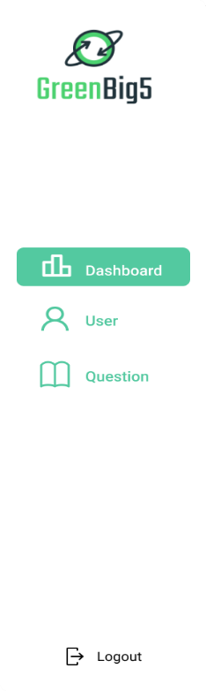

|  |  |  |  |  |
| --- | --- | --- | --- | --- |
| **Sidebar** | | | | |
| **No.** | **Field name** | **Type** | **Require** | **Target** |
| 1 | Logo | image |  | logo\_green.png |
| 2 | Menu | List & icon button | margin-top: 0.3rem;  padding: 13px 25px;  display: flex;  align-items: center;  font-weight: 600;  transition: color 0.2s ease 0s;  color: #4eb994;  position: relative  hover: color: #fff; | Dashboard, User, Question,  Logout |

## Dashboard page

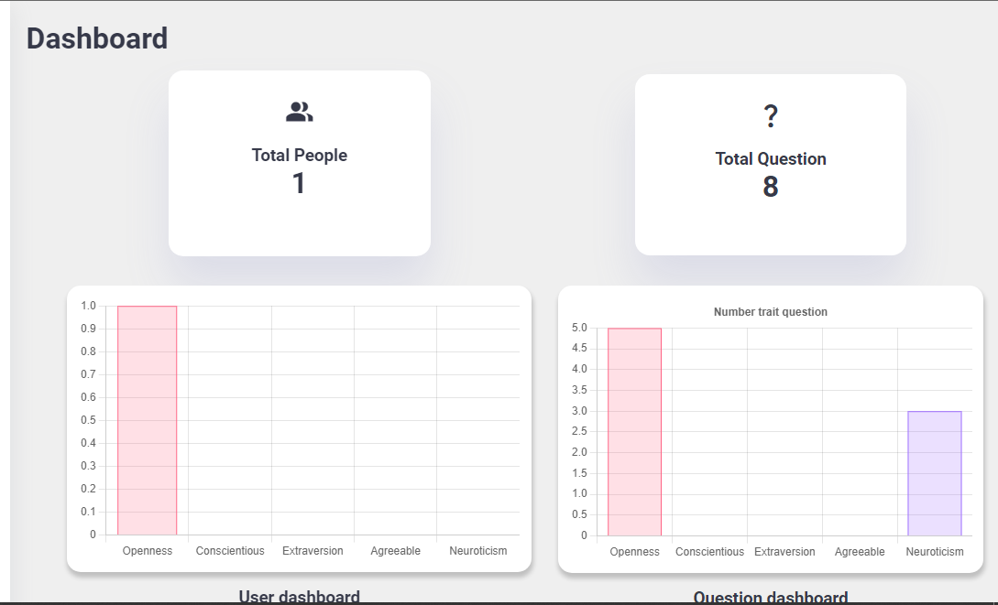

|  |  |  |  |  |
| --- | --- | --- | --- | --- |
| **Dashboard page** | | | | |
| **No.** | **Field name** | **Type** | **Require** | **Target** |
| 1 | Header | H1 | Color: #00000 |  |
| 2 | Card | div | background: var(--color-background);  padding: 1.8rem;  border-radius: 1rem;  width: 48%;  margin-top: 1rem;  box-shadow: var(--box-shadow); | Total people, total questions |
| 3 | Column chart | div | margin-top: 2rem;  height: 50%;  width: 100%;  background-color: white;  padding: 12px;  border-radius: 15px;  box-shadow: 1px 5px 5px 1px rgb(0 0 0 / 20%); |  |
| 4 | Pie Chart | div | Display: flex  display: block;  box-sizing: border-box;  height: 464px;  width: 464px; |  |

## User page

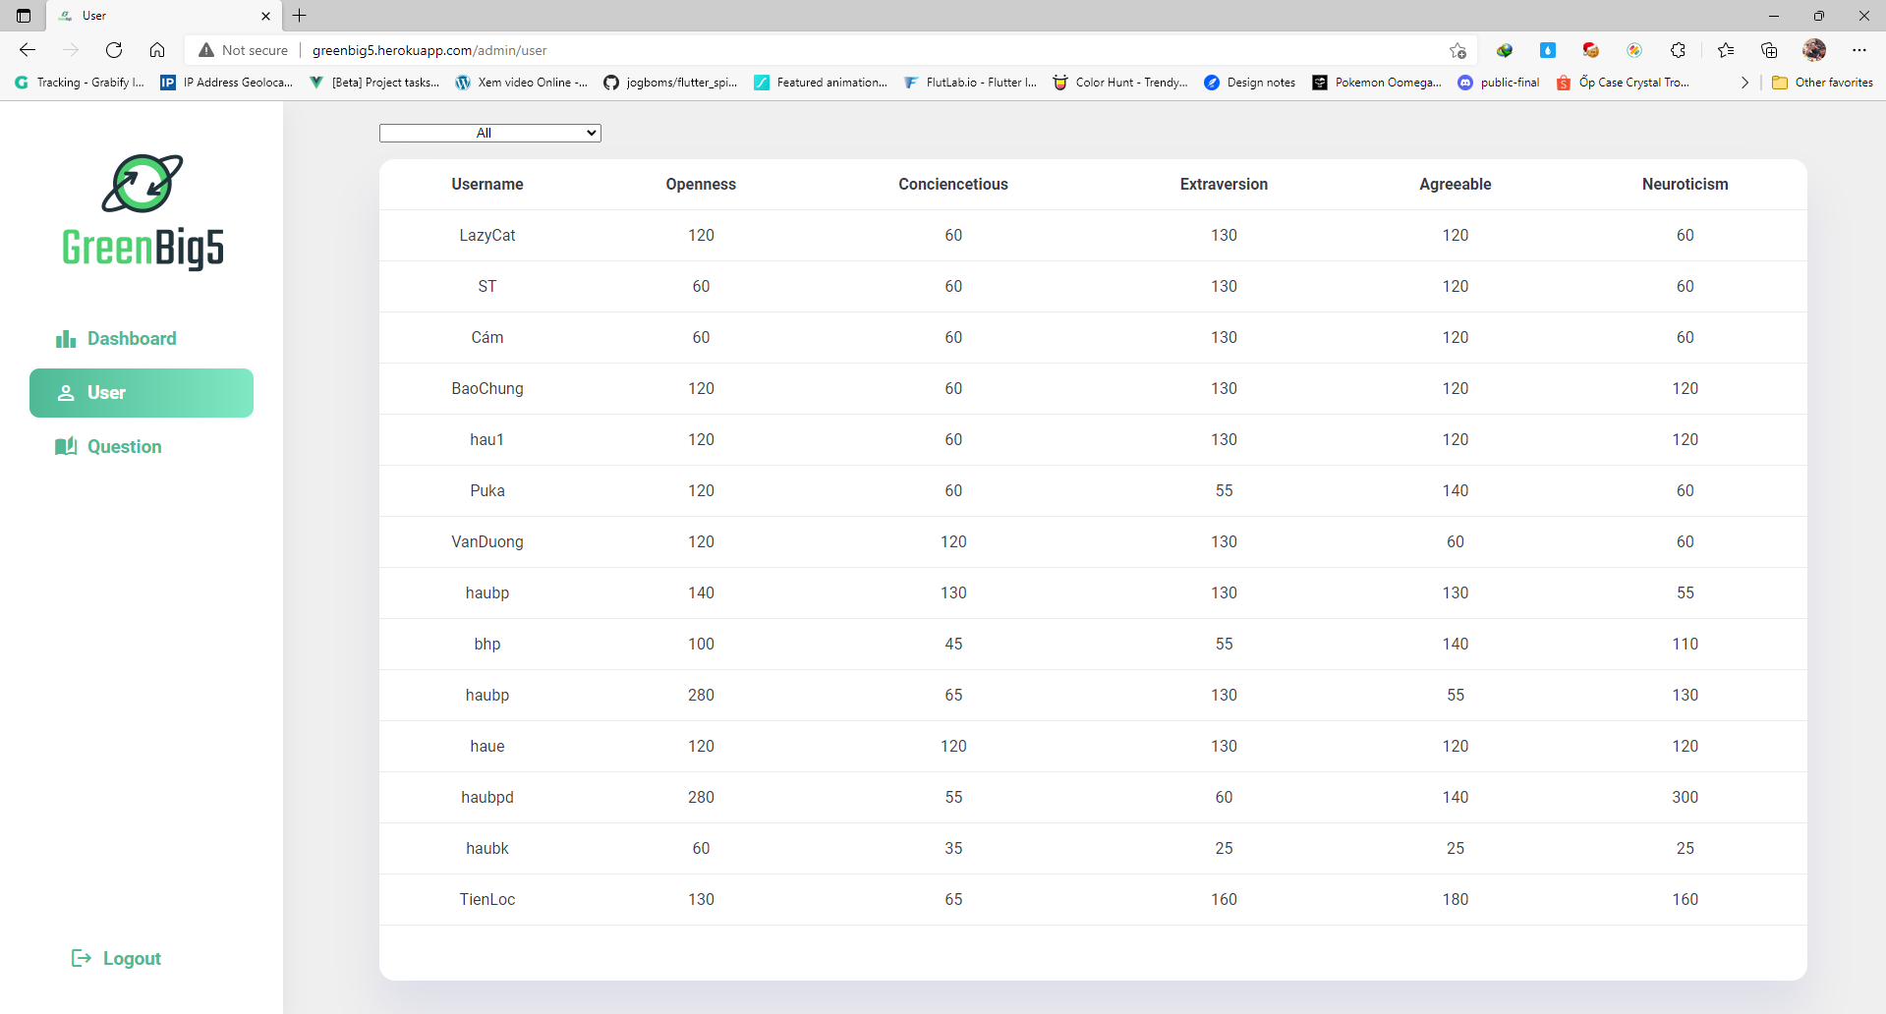

|  |  |  |  |  |
| --- | --- | --- | --- | --- |
| **User page** | | | | |
| **No.** | **Field name** | **Type** | **Require** | **Target** |
| 1 | Filter | Dropdown(Select tag) | All: Openness, Conciencetious, Extraversion, Agreeable, Neuroticism. | |
| 2 | Table | Table tag | margin: 0 auto;  width: 90%;  overflow-y: auto;  height: 70vh;  background:var(--color-background);  border-radius: 1rem; |  |

# DETAILED INTERFACE APPLICATION DESIGN

## Sign In page

## C:\Users\Admin\Downloads\263410768_932947374020260_877627630947904931_n.jpg

|  |  |  |  |  |
| --- | --- | --- | --- | --- |
| **Input Question Form** | | | | |
| **No.** | **Field name** | **Type** | **Require** | **Target** |
| 1 | Background |  | backgroundColor: Colors.white, |  |
| 2 | Header | Text | fontWeight: FontWeight.bold,  fontSize: 28.0 |  |
| 3 | Subtitle | Text | color: Colors.grey,  fontSize: 25.0, |  |
| 4 | Logo | Image |  | logo\_green.png |
| 5 | Input information | TextFormField | borderRadius:BorderRadius.all(Radius.circular(10.0)), | Phone number, password |
| 6 | Button | Button | fontSize: 20.0,  HexColor(“#2FBB89”)  borderRadius: BorderRadius.circular(12.0), | when onclick it go through the login process |
| 7 | Signup | Link | HexColor(“#2FBB89”) | When onclick make, you will be redirected to the signup page |

## Signup page

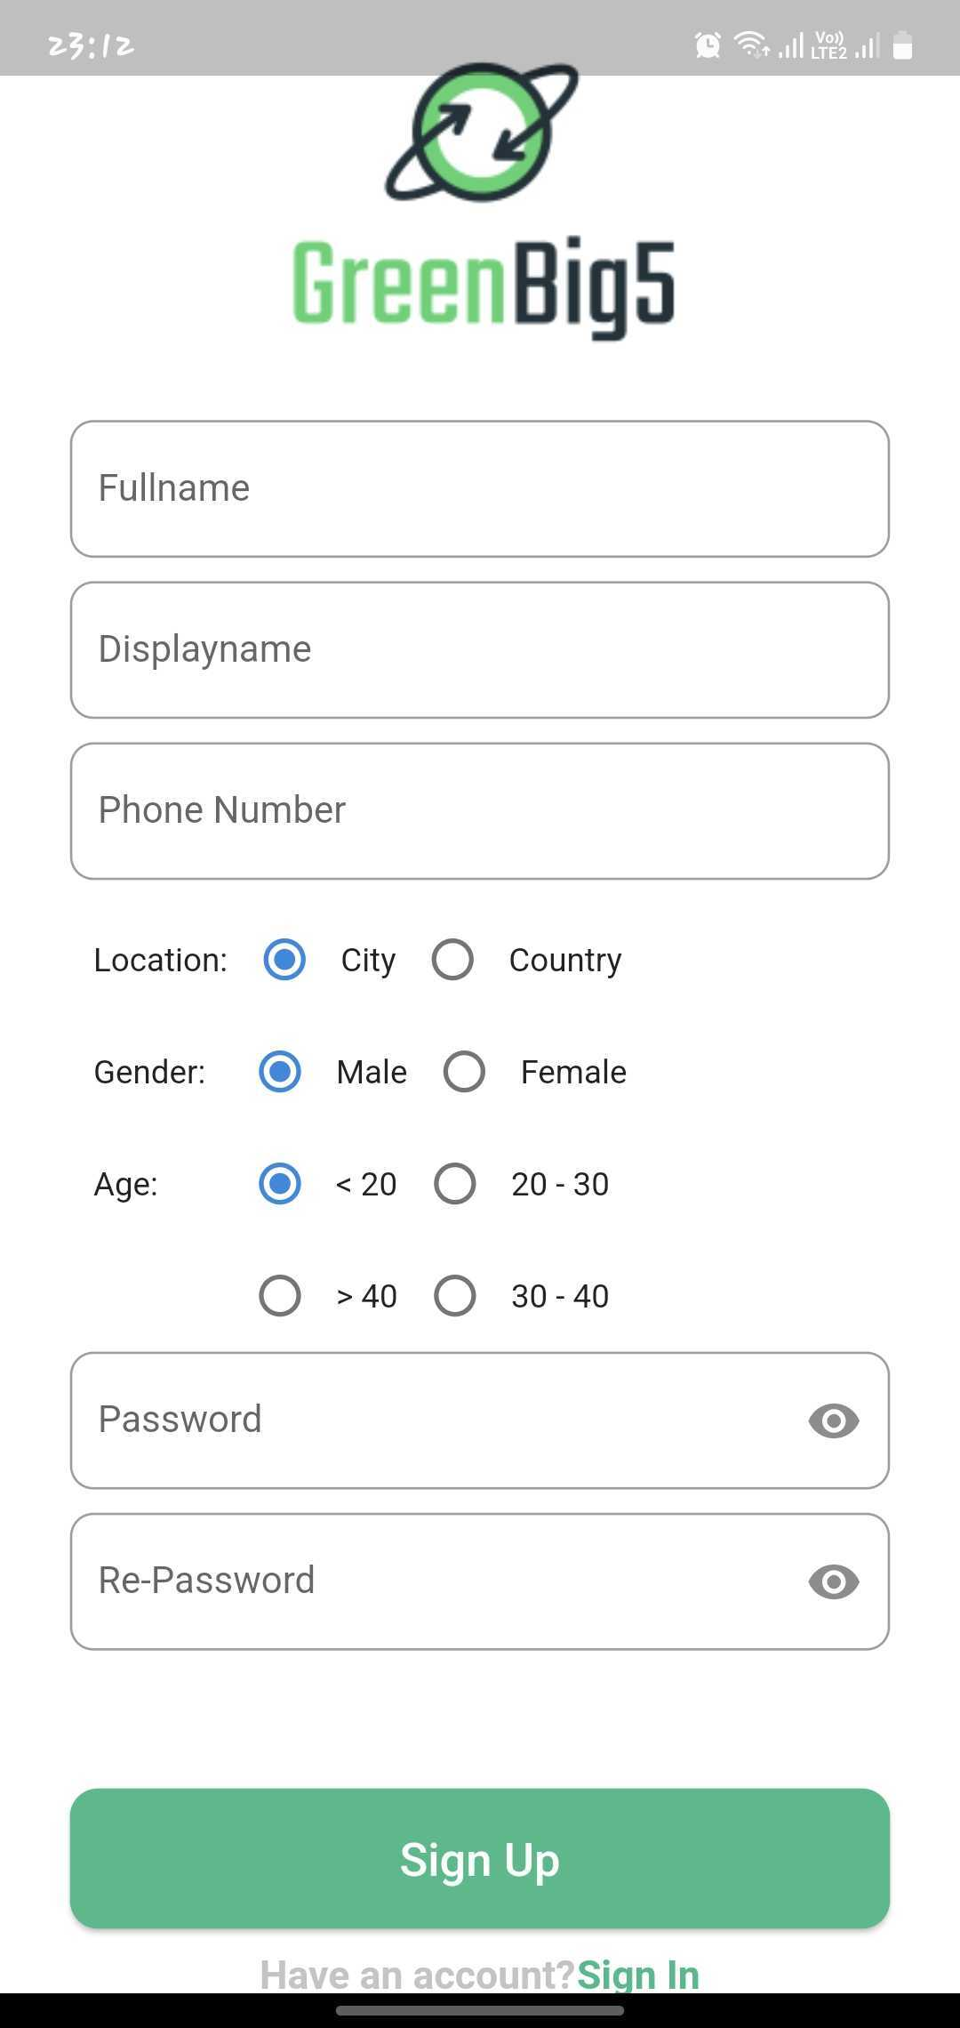

|  |  |  |  |  |
| --- | --- | --- | --- | --- |
| **Input Question Form** | | | | |
| **No.** | **Field name** | **Type** | **Require** | **Target** |
| 1 | Background |  | backgroundColor: Colors.white, |  |
| 2 | Header | Text | fontWeight: FontWeight.bold,  fontSize: 28.0 |  |
| 3 | Subtitle | Text | color: Colors.grey,  fontSize: 25.0, |  |
| 4 | Logo | Image |  | logo\_green.png |
| 5 | Input information | TextFormField | borderRadius:BorderRadius.all(Radius.circular(10.0)), | Full Name, Display Name,Phone number, password, Repassword |
| 6 | Radio | Radio Class | Radio<SingingCharacter> | (Location,Gender, Age). When you click you can change the properties you want |
| 7 | Button | Button | fontSize: 20.0,  HexColor(“#2FBB89”)  borderRadius: BorderRadius.circular(12.0), | when onclick it go through the login process |

## User information page

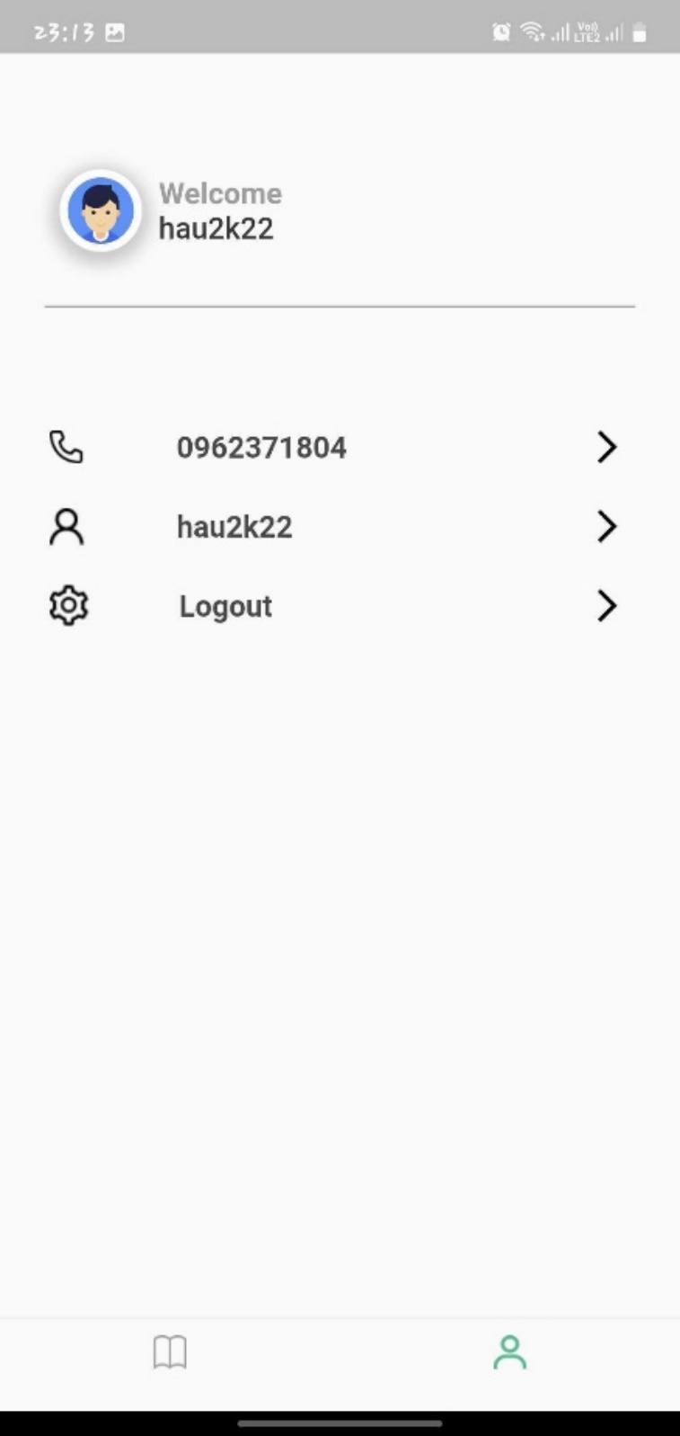

|  |  |  |  |  |
| --- | --- | --- | --- | --- |
| **Input Question Form** | | | | |
| **No.** | **Field name** | **Type** | **Require** | **Target** |
| 1 | Background |  | backgroundColor: Colors.grey, |  |
| 2 | Subtitle | Text | color: Colors.Gray,  fontSize: 24.0,fontWeight: Bold. |  |
| 3 | Name | Text | color: Colors.black,  fontSize: 22.0,fontWeight: Bold. |  |
| 4 | Logo User | Image | color: Colors.white, width: 5.0 | user.png |
| 5 | Change\_title | Text | fontSize: 18 |  |
| 6 | Icon | Icons class | fontSize: 18 |  |
| 7 | Icon\_active | Icons class | fontSize: 18 | When clicked will trigger the preset action |

## Change DisplayName, PhoneNumber page

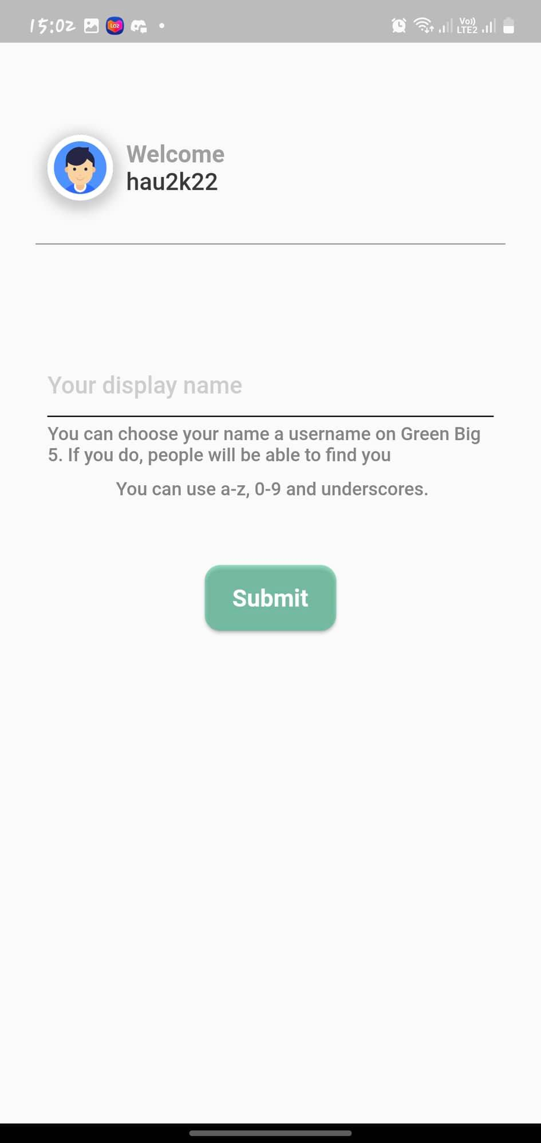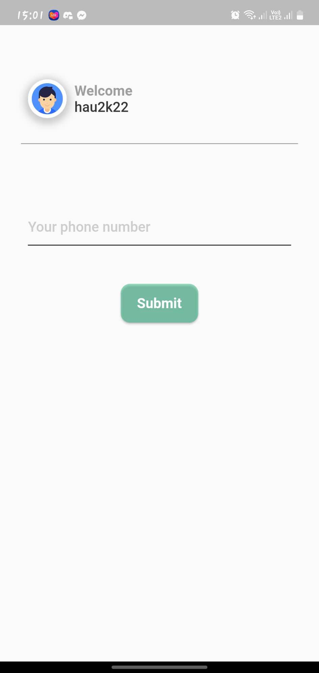

|  |  |  |  |  |
| --- | --- | --- | --- | --- |
| **Input Question Form** | | | | |
| **No.** | **Field name** | **Type** | **Require** | **Target** |
| 1 | Background |  | backgroundColor: Colors.grey, |  |
| 3 | Subtitle | Text | color: Colors.black,  fontSize: 24.0, |  |
| 4 | Logo | Image | color: Colors.white, width: 5.0 | user.png |
| 5 | Change form | TextFormField | fontSize: 18 | Enter to change your change information |
| 6 | Button | Button | fontSize: 20.0,  HexColor(“#2FBB89”)  borderRadius: BorderRadius.circular(12.0), | When onclick it change display name, phone number |

## Question page

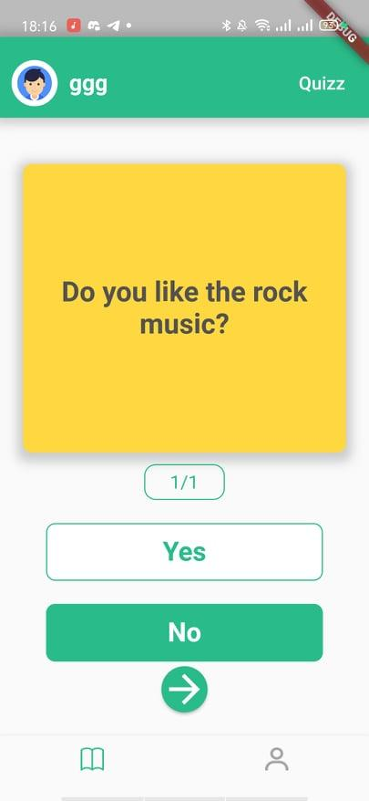

|  |  |  |  |  |
| --- | --- | --- | --- | --- |
| **Input Question Form** | | | | |
| **No.** | **Field name** | **Type** | **Require** | **Target** |
| 1 | Background |  | backgroundColor: Colors.grey, |  |
| 2 | Header |  | color: Colors.grey.withOpacity(0.5),  spreadRadius: 5, blurRadius: 7,  offset: Offset(0,0.2)  HexColor(“#2FBB89”) |  |
| 3 | Name | Text | fontWeight: FontWeight.w700, fontSize: 17.0,  color: Colors.white |  |
| 4 | Subtitle | Text | fontSize: 14.0,fontWeight: FontWeight.w500,  color: Colors.white, |  |
| 5 | Logo | Image | color: Colors.white, width: 5.0,  borderRadius: BorderRadius.circular(150.0), | user.png |
| 6 | Phone Number | TextFormField | fontSize: 18 | Enter to change your display name |
| 7 | Answer | Button (Option) | option(id, questionDefind, phoneNumber,"Yes",100.0),  SizedBox(width: 20.0,), option(id, questionDefind, phoneNumber,"No",100.0) | when onclick select the user's answer |
| 8 | Skip | Button (Option) | option(id,questionDefind,  phoneNumber,"Skip",250.0) | when onclick skip question |

## Logout

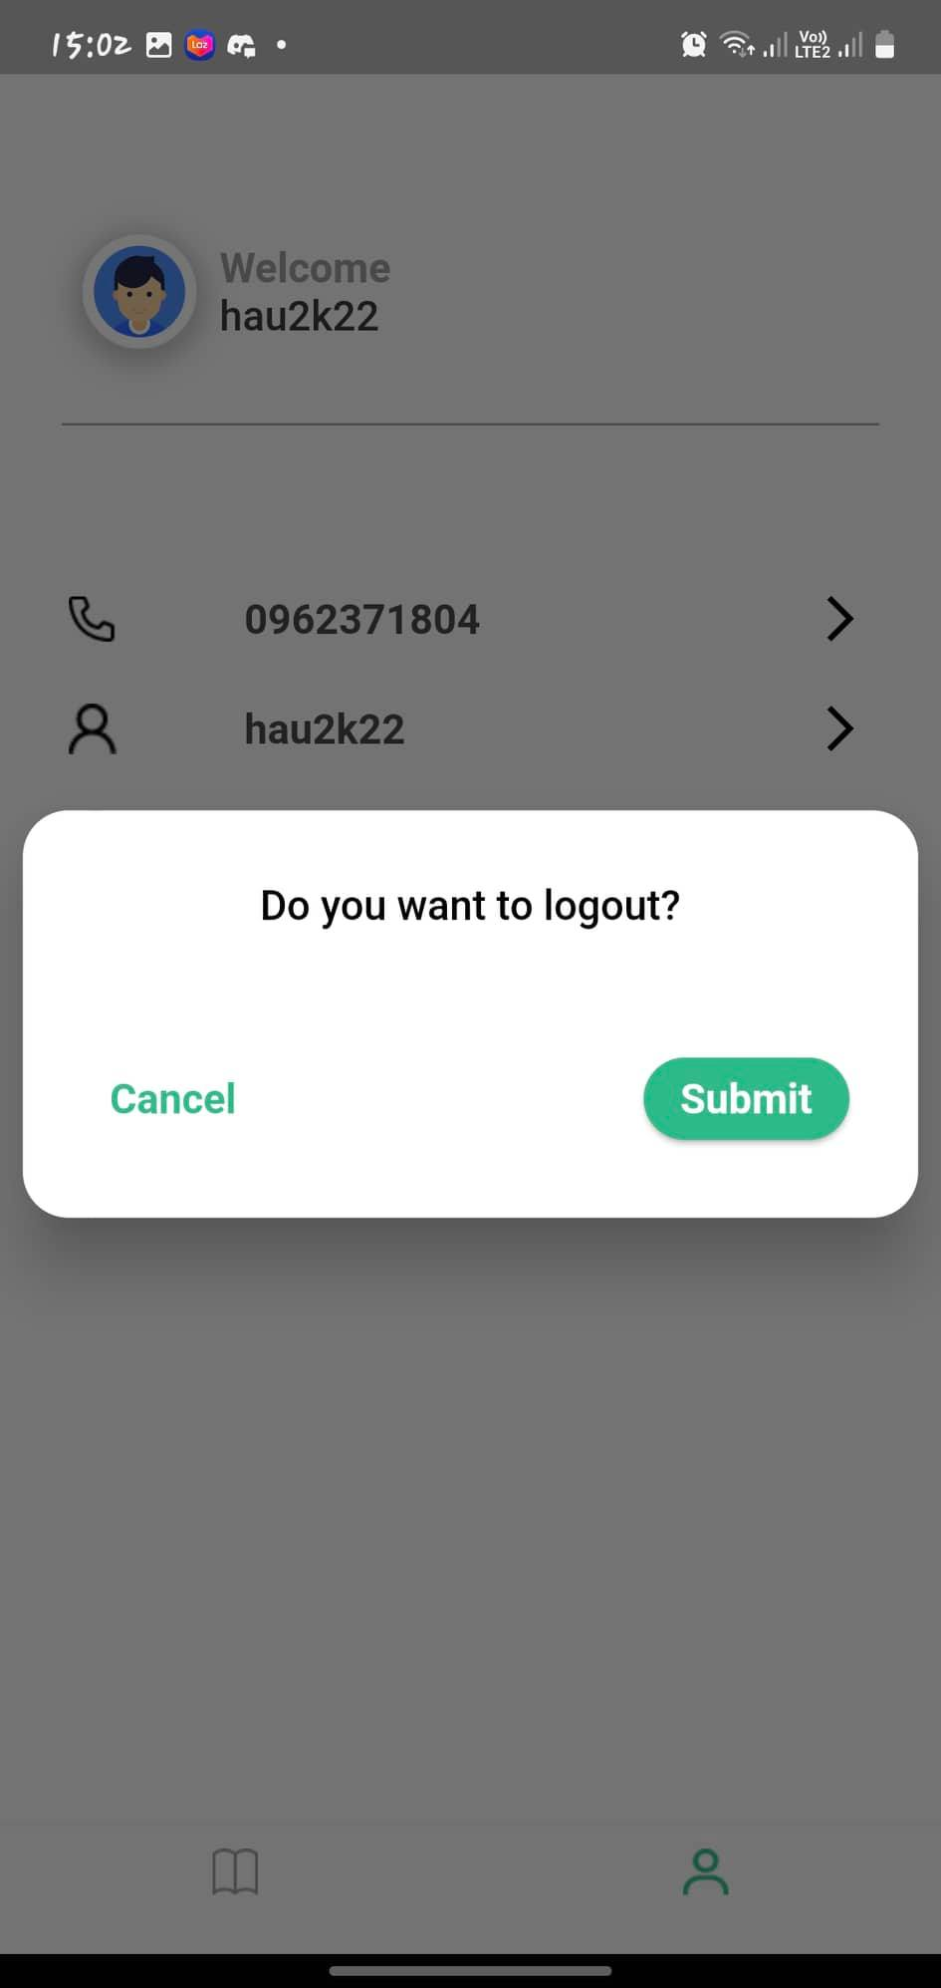

|  |  |  |  |  |
| --- | --- | --- | --- | --- |
| **Input Question Form** | | | | |
| **No.** | **Field name** | **Type** | **Require** | **Target** |
| 1 | Background |  | backgroundColor: Colors.white, |  |
| 2 | Title | Text | fontSize: 14.0,  fontWeight: FontWeight.w500,  color: Colors.white, |  |
| 3 | Cancel | Button | fontSize: 18,  FontWeight.w500,  color: (“#2FBB89”) | When onclick will exit the logout |
| 4 | Submit | Button | fontSize: 18,  color: Colors.white,  HexColor(“#2FBB89”)  borderRadius: BorderRadius.circular(12.0), | When onclick will submit the logout |

# DETAILED INTERFACE QUESTION WEB DESIGN

## Home page

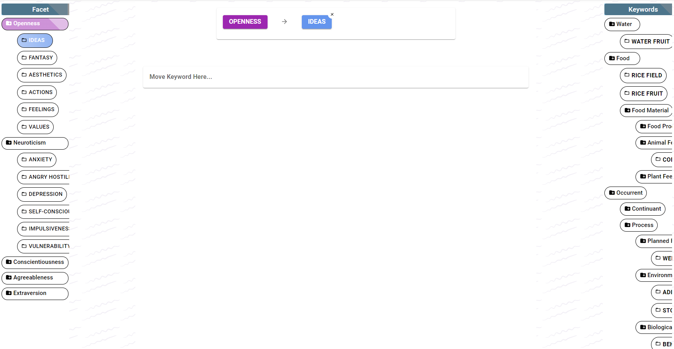

|  |  |  |  |  |
| --- | --- | --- | --- | --- |
| **Input Question Form** | | | | |
| **No.** | **Field name** | **Type** | **Require** | **Target** |
| 1 | Background |  | backgroundColor: rgb(255, 255, 255) |  |
| 2 | Tree data | Ul tag | display: block !important; transition: all 2s;  border-radius: 50%;  fontsize: 14, font-weight: 500; | Facet, Keywords |
| 3 | Button | Button | border-radius: 50%;  fontsize: 14, font-weight: 500; | When onclick the data will drop down & move the button to the middle position to create a data tree |

## Navbar



|  |  |  |  |  |
| --- | --- | --- | --- | --- |
| **Input Question Form** | | | | |
| **No.** | **Field name** | **Type** | **Require** | **Target** |
| 1 | Background |  | -webkit-box-flex: 1; flex-grow: 1; background-image: url(https://ak.picdn.net/shutterstock/videos/10205426/thumb/1.jpg); background-repeat:no-repeat; background-size: cover; background-position: right center; padding: 0px; |  |
| 2 | Tittle | Text | Color: #ffffff  fontsize: 20, font-weight: 500; |  |
| 3 | Notification | Button | fontsize: 14, | When onclick the notification will drop down |

## Notification

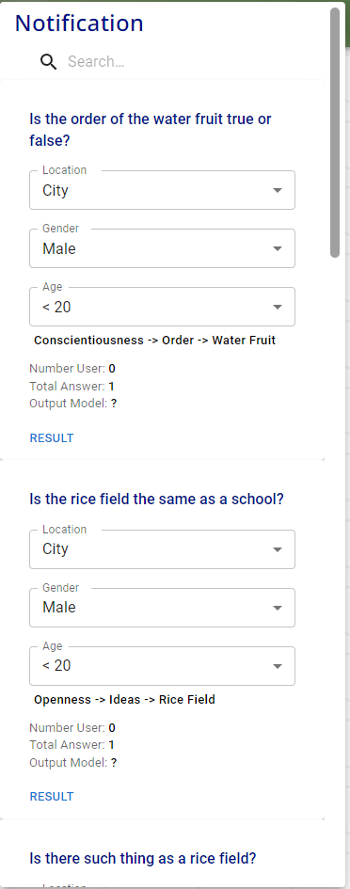

|  |  |  |  |  |
| --- | --- | --- | --- | --- |
| **Input Question Form** | | | | |
| **No.** | **Field name** | **Type** | **Require** | **Target** |
| 1 | Background |  | background-color: rgb(255, 255, 255); color: rgba(0, 0, 0, 0.87); transition: box-shadow 300ms cubic-bezier(0.4, 0, 0.2, 1) 0ms; border-radius: 4px; box-shadow: rgb(0 0 0 / 20%) 0px 5px 5px -3px, rgb(0 0 0 / 14%) 0px 8px 10px 1px, rgb(0 0 0 / 12%) 0px 3px 14px 2px; position: absolute; overflow: hidden auto; min-width: 16px; min-height: 16px; max-width: calc(100% - 32px); max-height: calc(100% - 32px); outline: 0px; |  |
| 2 | Tittle | Text | color: #001188 !important; padding: 5px; font-size: 24px !important; font-family: 'Noto Sans', sans-serif !important; margin-left: 10px !important; |  |
| 3 | Search | Text field, Button | padding: 8px 8px 8px calc(1em + 32px); transition: width 300ms cubic-bezier(0.4, 0, 0.2, 1) 0ms | When type will automatically search by keyword |
| 4 | Question information | Select tag | appearance: none; user-select: none; border-radius: 4px; cursor: pointer; font: inherit; letter-spacing: inherit; color: currentcolor; border: 0px; box-sizing: content-box; background: none; height: 1.4375em; margin: 0px; -webkit-tap-highlight-color: transparent; display: block; min-width: 0px; width: 100%; animation-name: mui-auto-fill-cancel; animation-duration: 10ms; padding: 16.5px 14px; | Location, Gender, Age  When onclick the (Location, Gender, Age) select the state you need to change |